Finance Investment Project – Winter 2018/19

Components of the assignment: The assignment requires the use of Word, Excel and the Internet, all in the context of finance.
- (Word) Define and give the purpose of the Dow Jones Industrial Average (DJIA). Explain what the NASDAQ is. Explain what the S & P 500 means. Why are these indices important? Why would a LIM student, business owner, and economist be interested in these indices? (30 points)
The Dow jones industrial average (DJIA) is a stock market index that consist of 30 large US based company. The DJIA is used as a benchmark for the 30 large companies’ performance in the stock exchange market. Its main purpose is to indicate the average performance and value of the 30 companies included in DJIA index. NASDAQ is a stock exchange market in the United States where most of the technical-based firms are listed and stocks traded. The market adopts its average index for the firms that trade in the stock exchange market identified as Nasdaq. More so, NASDAQ is ranked the second largest stock exchange market on the merits of market capitalization of over $10 trillion. S & P 500 refers to a stock market index that constitutes of 500 best performing company stocks. The Nasdaq market index is a useful standard index for companies in the NASDAQ stock market as it represents the average valuation of the stocks’ performance in the market. The index is used as a standard benchmark for all publicly traded stock since it comprises of the average value of 500 best performing publicly traded stocks. The indices are important in stock value assessment since they act as the standard metric of performance measure for other public traded stocks. An investor would be interest in the indices as they are the primary metrics that reflects the performance in the stock market as well as a benchmark for comparing the performance of other stocks in the stock market. More so, the indices are useful in the determination of risk and return parameter of other stocks in the stock market.
- (Internet) Go to the Yahoo Finance site ( http://finance.yahoo.com ), click the Dow link (upper left side of window). Go to the basic chart (link on the left) and then click the 1y (one year) link under the chart. When the chart of the Dow appears, click on the comparison tab and add NASDAQ and S & P 500. Print it and hand it in as part of your project. (5 points)
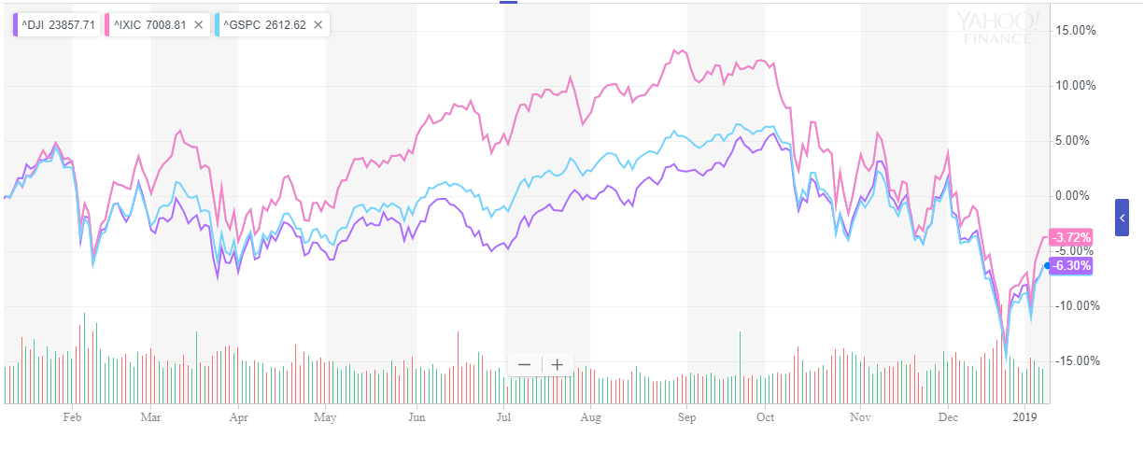

- (Word) Using the above print out (#2), explain the performance of the three indices for the past 12 months. From your personal perspective, why do you think a particular index performed the way it did? (20 points)
Over the past one year, the performance of the Dow jones industrial average, Nasdaq and S & P 500 has been progressive from the early stages of the year. More so, all the three indices are evenly matched in value in the first month but differ in the following periods. Nasdaq index has the highest value over the 11-month period while that of DJIA and S & P 500 indices move closely together over the same period. However, Nasdaq average return after the 1-year period is -3.72% which indicates a loss in value alongside DJIA and S & P 500 indices which had a loss return of -6.30%. The rate of return of the indicates are useful indicators of the actual performance of the indices stocks. In essence, the performance of Nasdaq stock experiences a great drop in the index value especially in the closing periods falling as low as the valuation of the other two indices. The performance of NASDAQ index easily catches the eye which necessitate a closer assessment. On a more intensive assessment, the stock loses value during the year’s period while its price fluctuation also indicates that it accrues a high risk as compared to the rest of the indices stocks.
- (Internet) Pick a publicly owned company in which you are interested. Use the symbol lookup link in Yahoo Finance to find the symbol for your company. You will need this symbol to answer some of the questions below.
The company of interest if Microsoft Corporation which trades in the NASDAQ stock market. The current valuation of the stock is at $102.80. in addition, the stocks market capitalization currently stands at $789.248 billion.
- (Word) Give the name of the company and its symbol.
Microsoft Corporation with the abbreviation of MSFT in the stock market.
- (Internet) Enter the symbol for your chosen company in order to compare it to the Dow on your Yahoo chart for 1y (one year). Print the Yahoo graph showing the Dow and your company and attach it to your project. (5 points)
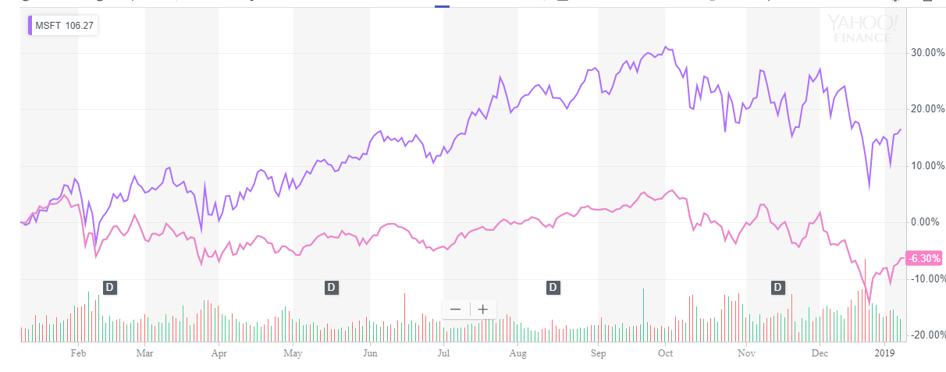
- (Word) Describe the movements in the DJIA during the year you charted. Based on the change in the DJIA during the year you charted, would you conclude that that was a good year, a bad year, or somewhere in between for stock investors generally? Why? (10 points)
Relative to the performance of the Microsoft corporation stock, DJIA performance was lower although it does not experience high price fluctuation as the Microsoft stock. Regardless, both stock experience a sharp dip in performance at the close of the period although DJIA stock has a lengthy dropping trend from October, 2018. In summary, the loss in value which is indicated by a rate of return of -6.30% over the period as compared to that of Microsoft of 16.46%, it was a bad year for investors in the DJIA stock. The investors of the stock lose value by a greater margin as compared to the investors of the Microsoft stock which gains value substantially. The absolute performance of the DJIA stock is poor in the same way its relative performance against the Microsoft stock is, which sums up the challenges of dip in value especially in the closing periods of the year.
- (Word) How did your chosen stock perform relative to the overall market during this period? Comment briefly, indicating the basis for your conclusion. (10 points)
During the period of comparison of the Microsoft stock against the DJIA stock, it is evident that MSFT stock registers an excellent performance and outperforms the DJIA stock by a great margin. An investment in Microsoft stock in the last year leads to a return amounting up to 16.45% gain on the value of the investment. The stock has had an incredible year regardless of experiencing shaky periods towards the end of the year where there is a sharp decline in the value of the stock. Relatively, Microsoft stock represents a better investment as it outperforms the DJIA stock by a huge margin.
- (Word) Choose two financial ratios that we have discussed in this class. Refer to the stock you chose in #4. For that company, find the ratios you chose either on the yahoo finance or on MSN moneycentral sites (http://money.msn.com/) . Explain what the chosen ratios tells you about your company. Are you impressed positively or negatively by that ratio for your company? Why? (20 points)

